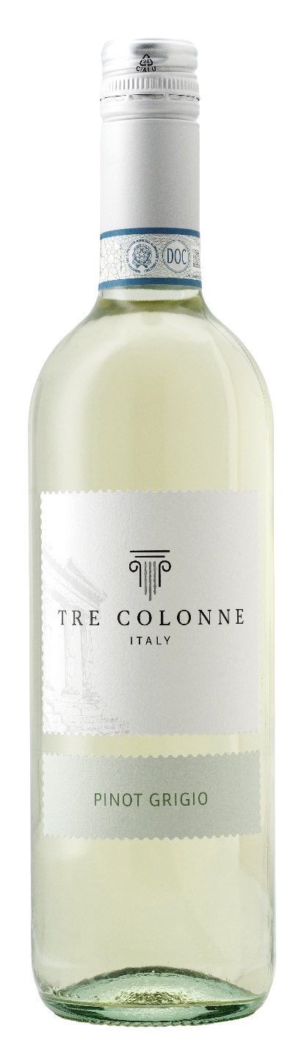
PINOT GRIGIO DOC DELLE VENEZIE – TRE COLONNE

Grape: Pinot Grigio 100%
Alc. Vol.%: 12
Vintage: 2025
Residual sugar g/l: 4,8
Total acidity g/l: 5,7
Region: Veneto
Production zone: Vineyards in the Venezie area
Capacity: 750ml

CHARACTERISTICS

Vinification: Fermentation of the grape must at a controlled temperature
Colour: Straw yellow with greenish reflections
Bouquet: Elegant, fruity and flowery
Flavour: Fresh, smooth and harmonious

SERVING SUGGESTIONS

Best enjoyed with fish dishes and seafood and light starters.
Serving temperature 8 °C
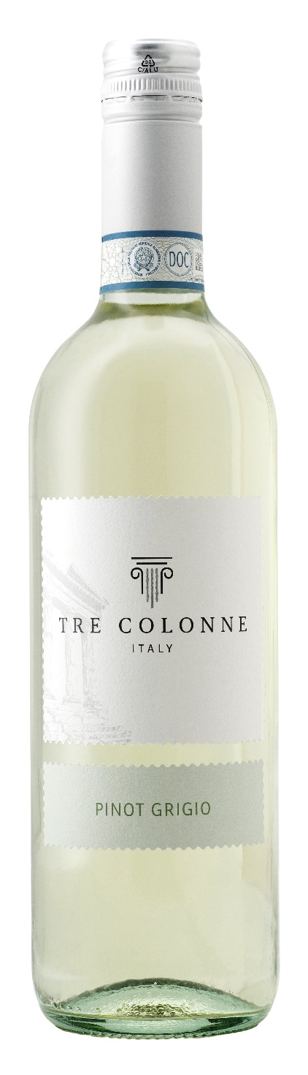
TECHNICAL INFORMATION / PALLETIZING

Size 750ml:
Article Nr. V14012A
GTIN-13 bottle 8017868005018
GTIN-13 carton 8017868005551
Closure Cork/Screwcap
Bottles / carton 6 bottles
Pallet size 80x120cm
Cartons/layer 25
Cartons/pallet 125
Kg/carton 7,0
Kg/pallet 892

Contains sulphites
GMO Free
Revisione 01. 14.05.2026

